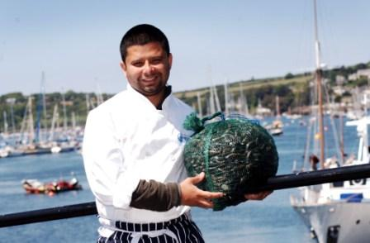
Fish head kedgeree

When it comes to cooking up something comforting and easy to eat, I always opt for rice and spice. My mum says your brain cells get sharper if you eat fish heads! Kedgeree is a staple Bengali Indian rice dish, that literally means mish mash and is typically associated with heavy monsoon days. Often prepared outdoors by Indian cooks (Bawarchee) for their itinerant British Civil service masters working away in remote places. My recipe for kedgeree a renowned Anglo Indian dish in Victorian England includes smoked mackerel, all the good juicy bits of a fish head, with eyes cheeks and all, through it. The dish is finished with wilted kale, rice perfumed with cardamom pods, a protein shot of lentils with a soft boiled eggs on the top.
To serve 2

1 large fish head /I prefer Hake or cod
1 Filet Cornish Oak smoked mackerel
2 eggs
120g basmati white rice
50 g Puy lentils washed
1 Red onion
1 tbsp freshly grated ginger
Oil for frying onions
1 tsp of Garam masala curry powder
125 g spinach/kale from the allotment
Fresh coriander leaves /parsley from allotment
1 Lemon

Bring a large pot of water to boil for 15-20minutes , with a table spoon of turmeric, coriander stalks and the cleaned fish head. Keep aside and the head as intact as possible.
Thinly slice half an onion and cook it on a low heat for about 10 minutes in 25ml of vegetable oil.(Mum prefers Ghee/clarified butter), until it is soft and golden. Add the grated ginger and cook for another 5 minutes.
Add a teaspoon of garam masala(hot-spice) powder and cook for another 3 minutes.

While the onion is cooking bring a small pan of water to a simmer and lower in 2 eggs, let them continue to simmer for 6 minutes. When they are ready run them under a cold tap so you can handle them and gently remove the shell. You should be able to cut the into quarters.

Put 120g of basmati rice and 50 g of red lentils in a small pan with 1 cardamom pod and a good pinch of salt, add 250ml of the fish stock from the pan with boiled fish head, let it simmer with the lid on for 8-10 minutes, or until the water has gone; then turn the heat off and allow it to sit for 10 minutes continuing to steam with the lid on.

Add 125g of washed spinach/kale, into the onions and allow it to wilt, then add the cardamom fragranced rice. Flake in the smoked mackerel fillet and allow everything to warm through. Add salt and pepper to your taste and a good squeeze of lemon. Finally place the cooked rice and lentils in a shallow serving dish, place the cooked fish head in the middle along with some quartered soft egg on the top and serve. The mixture of curried onions, cardamom rice/lentils and flaky fish is just lush.

Who dares to look the fish in the eye, and scoop it out to eat? Arrrrrghhhhh!

