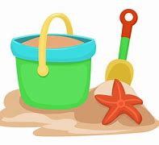

In Literacy we will continue reading and discussing our book of the week as well as using our skills we have learnt in our phonics sessions to write super sentences! We will be focusing on using capital letters, finger spaces and full stops in our writing as well as making sure we are forming all our letters correctly ready for our transition to year 1.

We are continuing to work our way through phase 4 phonics learning:

* Phase 3 long vowel graphemes with adjacent consonants • CVCC CCVC CCCVC CCV CCVCC
* words ending in suf‑xes: –ing, –ed /t/, –ed /id/ /ed/, –ed /d/ –er, –est

and practicing all the tricky words we have learnt so far.

On Monday. Wednesday and Fridays your child will continue group reading session where we read the Little Wandle books that they have sent home. We will focus on decoding, prosody and comprehension skills in these sessions.

We will be exploring the season of Summer and the changes there are as well as looking at differences in environments.

In RE we will be talking about which stories are special and why?

Expressive Arts and Design

Our focus this half term is designing and exploring how we can use different materials. We will use these skills to make boats.

This half term we will revise what we have learnt so far looking at patterns within numbers up to 10, including evens and odds, double facts and how quantities can be distributed equally.

We will explore teen numbers and the composition of them as well as shape and patteren.

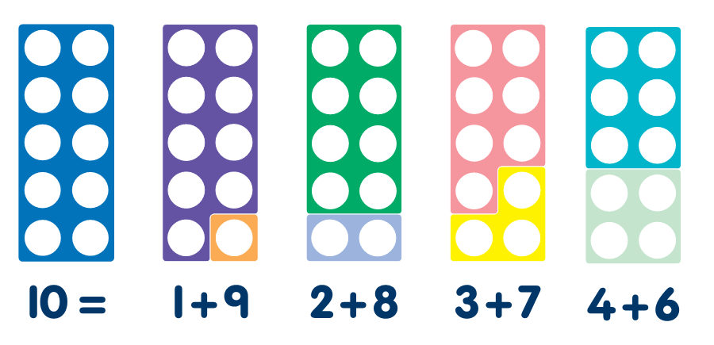

Physical Development

In PE this half term we will continue swimming. We will gain water confidence, talk about water safety and enjoy having time to splash about with our friends.

**EYFS**

**Summer Term 2**

Seaside Summers

5th June – 25th July

Understanding the World

Communication and language will continue to be a focus this term. We will have a focus book each week as well as a song of the week and word of the week.

Maths

Literacy

During our Jigsaw sessions we will explore ‘Changing Me’. We will have a different focus each week such as changes from babies to adults, moving to year 1 and memories from our first year at school.

Communication and Language

Personal, Social and Emotional Development